Contents

1. Drill And Art Works 1

1.1. Change Board Outline’s Undefined Line Width to Non Zero Value 2

1.2. Change Drill’s Undefined Line Width to Non Zero Value 3

2. Pick and Place File Export 9

2.1. First File 9

2.2. Second File 11

# Drill And Art Works

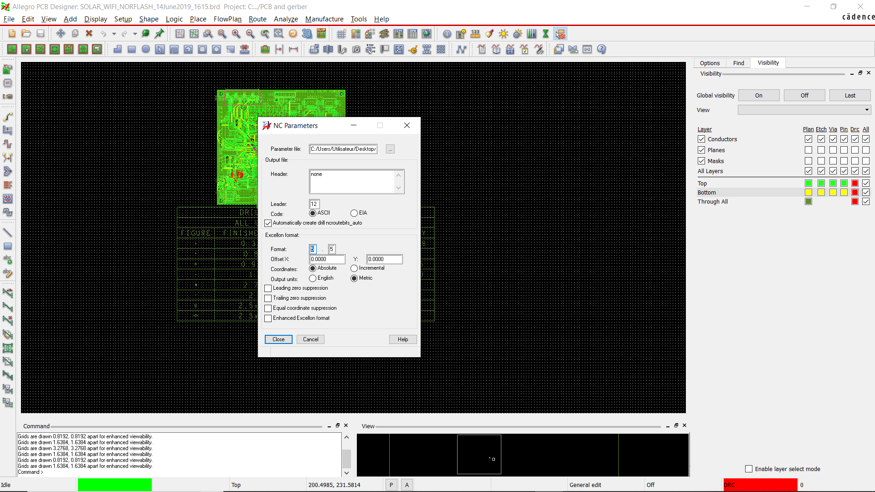

## Change Board Outline’s Undefined Line Width to Non Zero Value

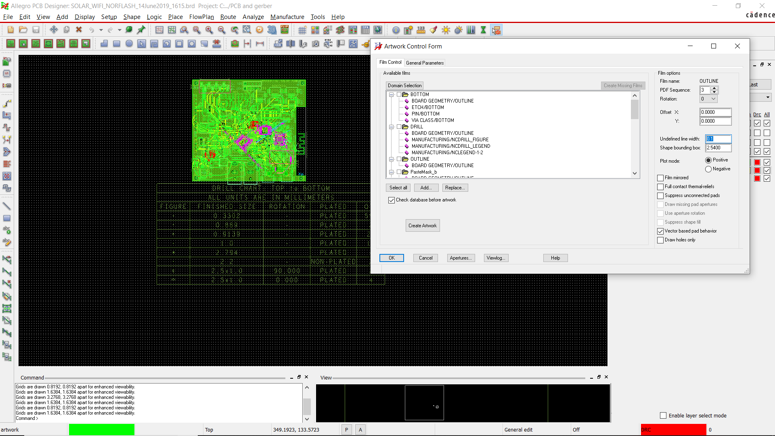

## Change Drill’s Undefined Line Width to Non Zero Value

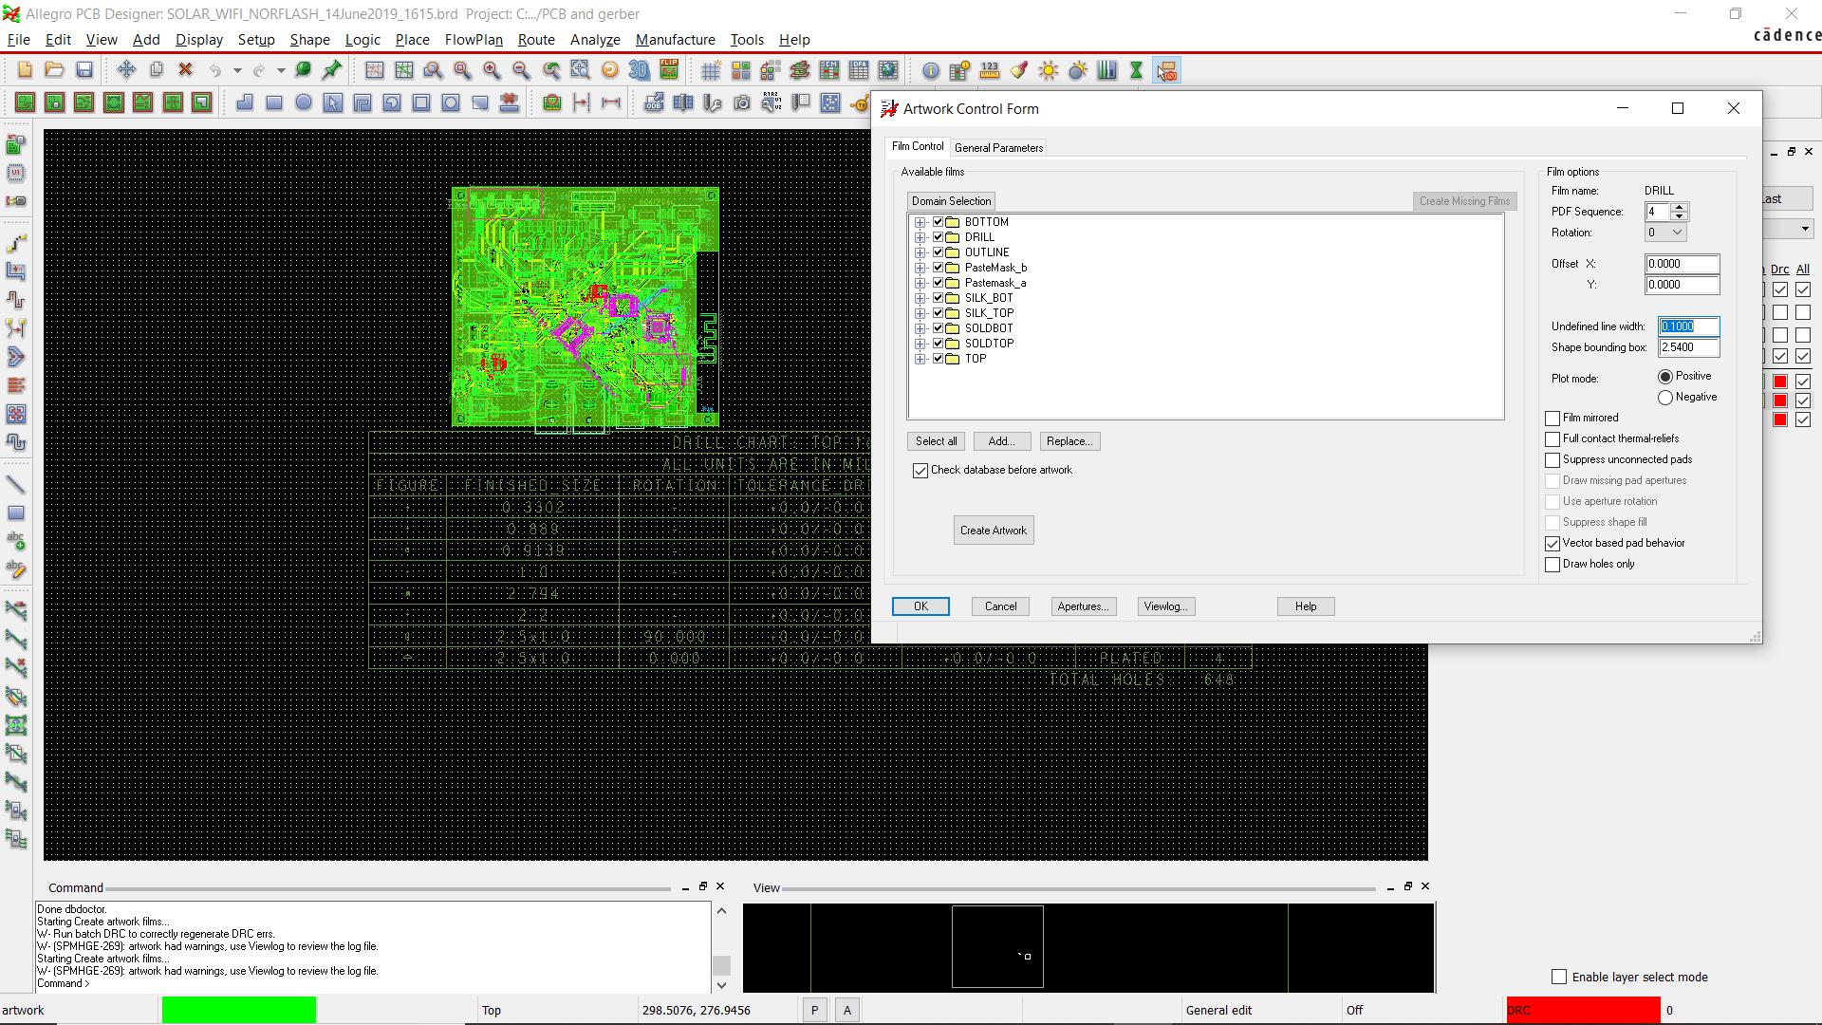

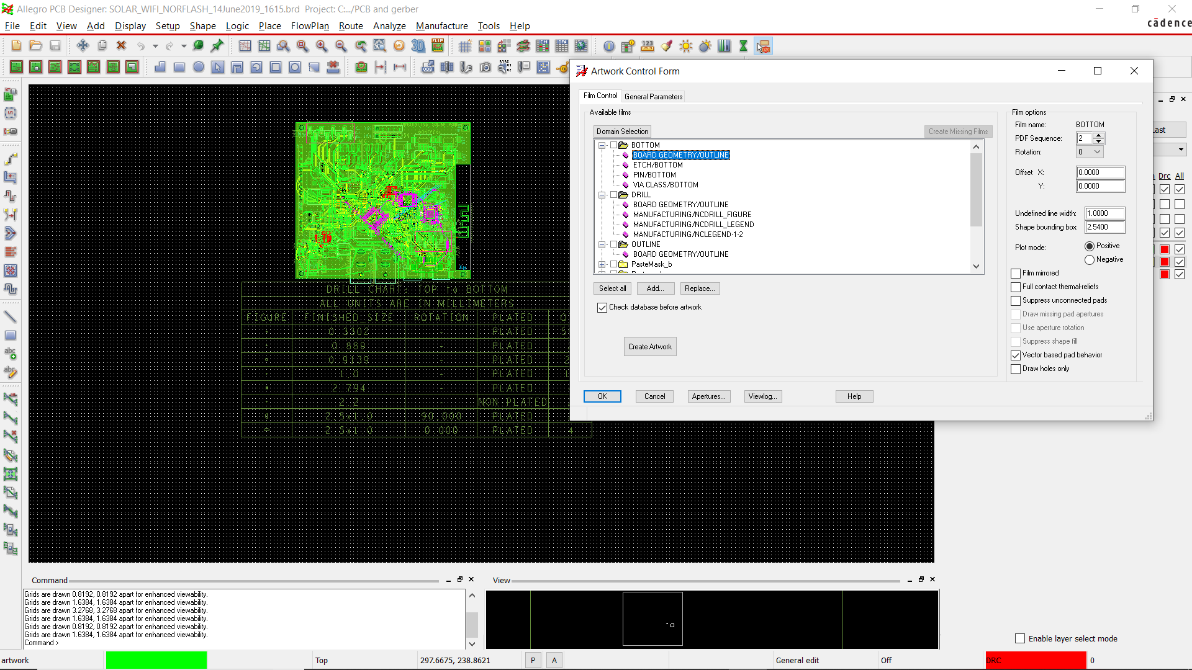

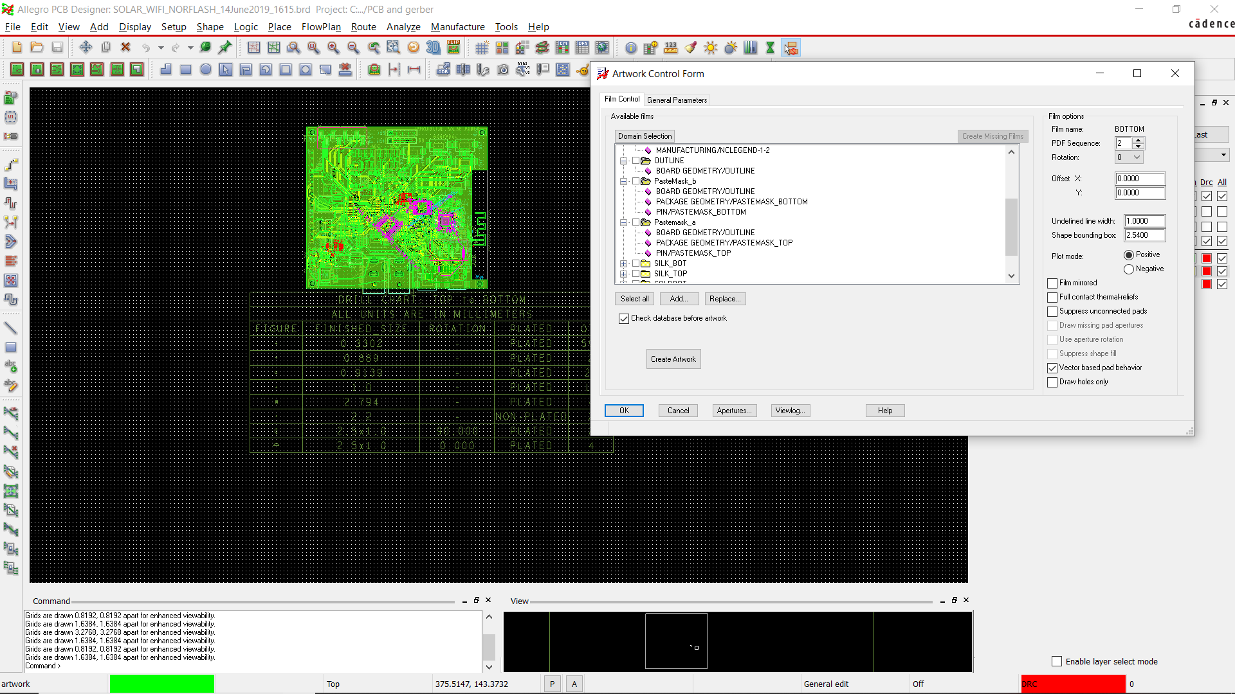

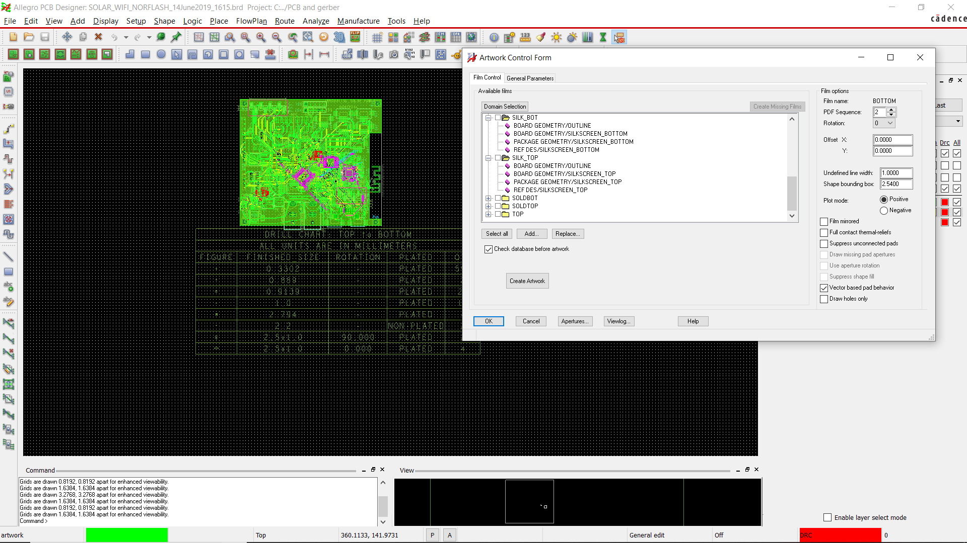

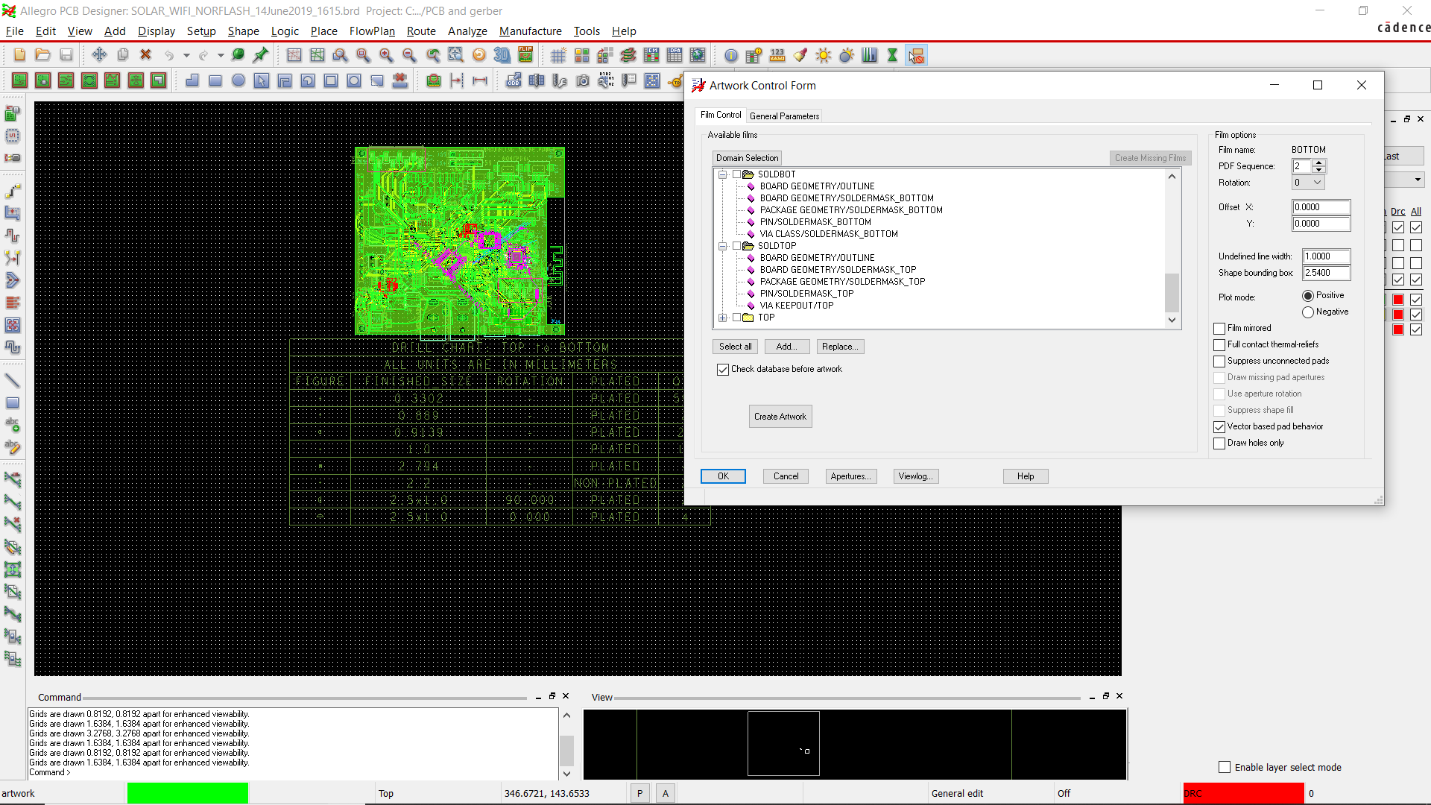

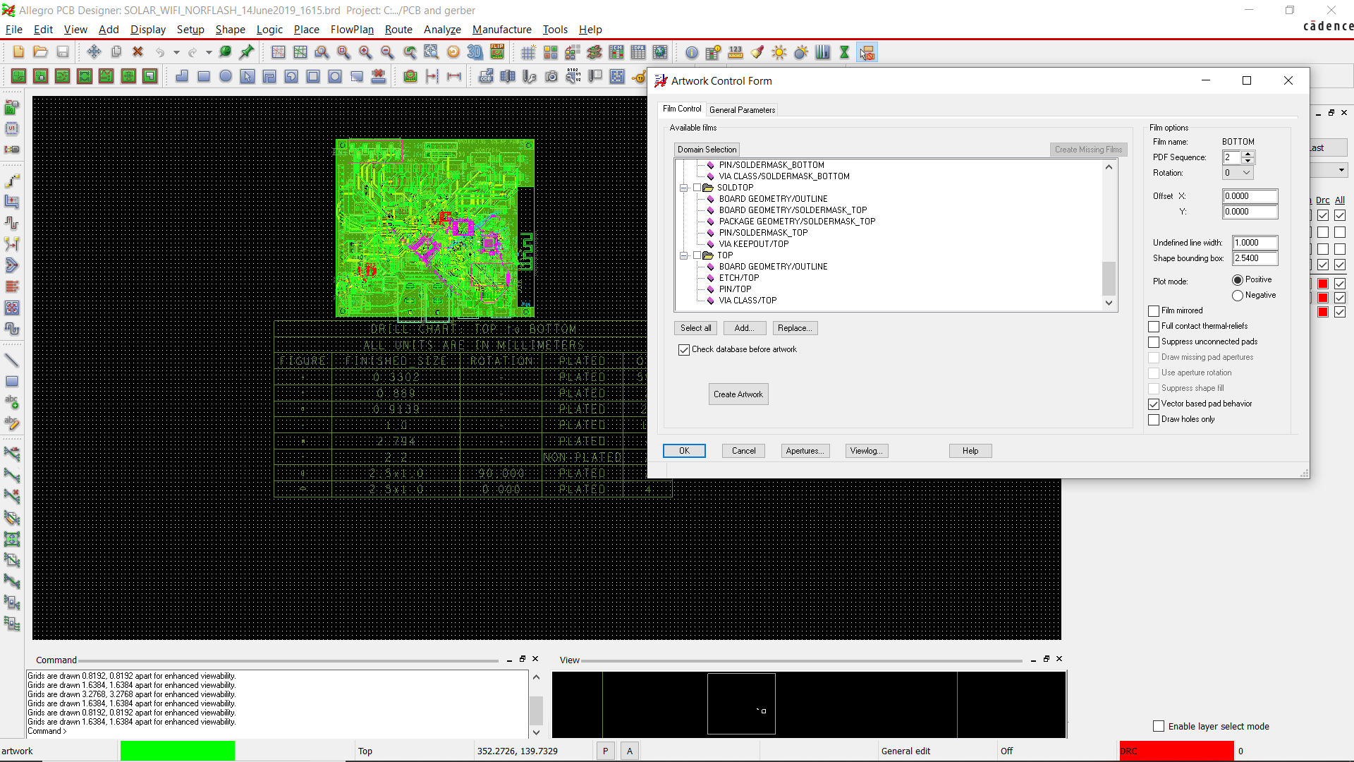

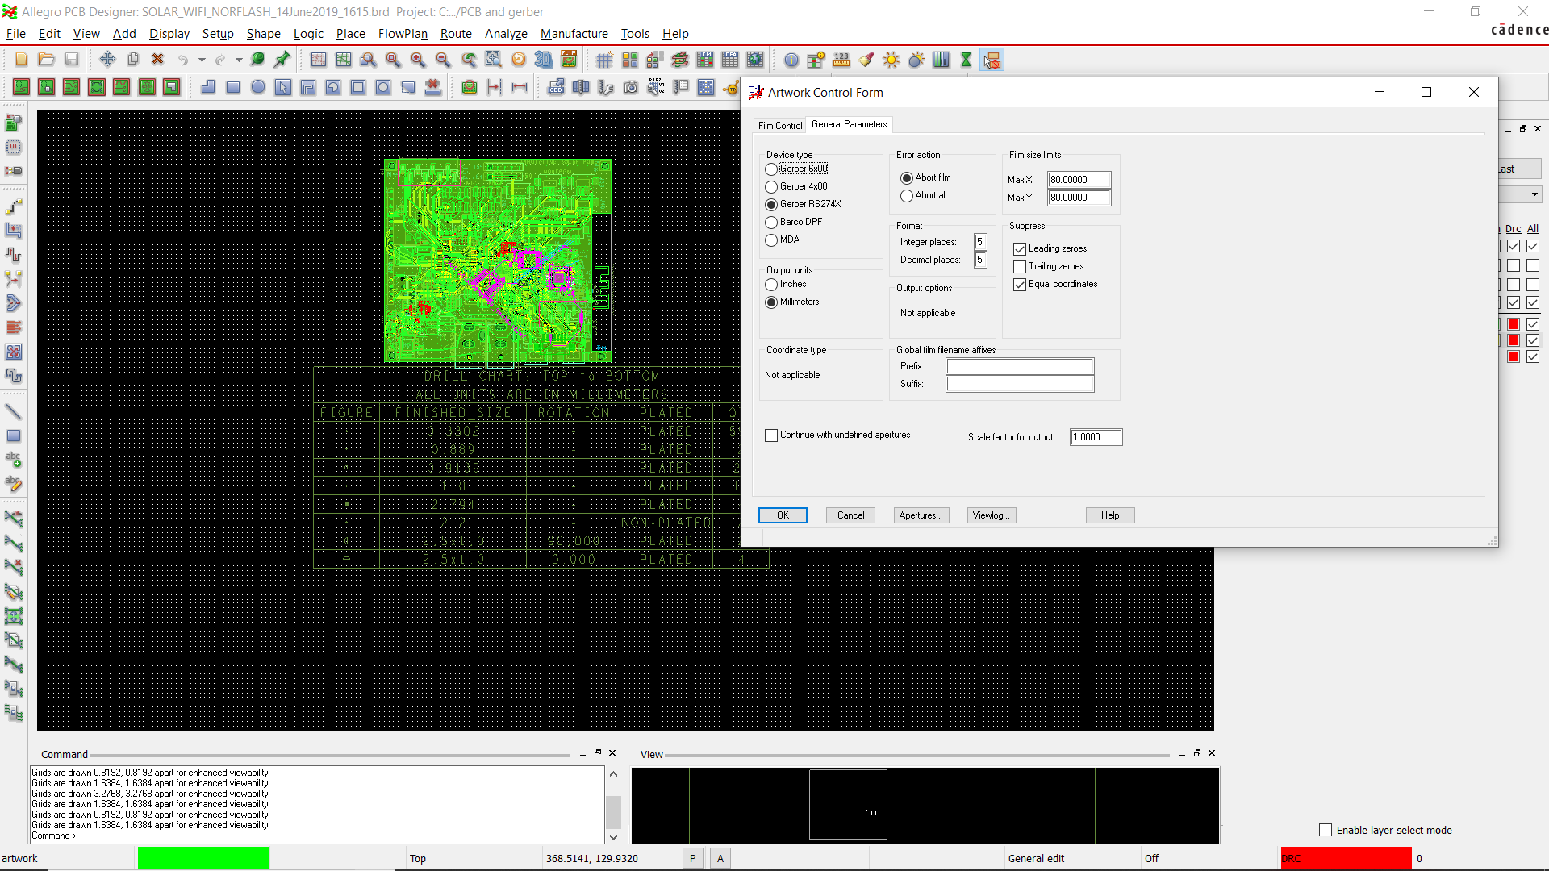

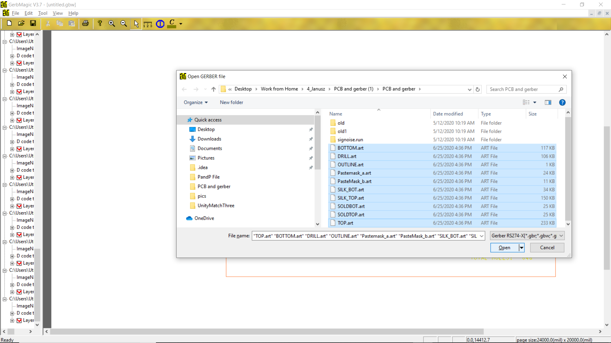

Double Check with GerbMagic

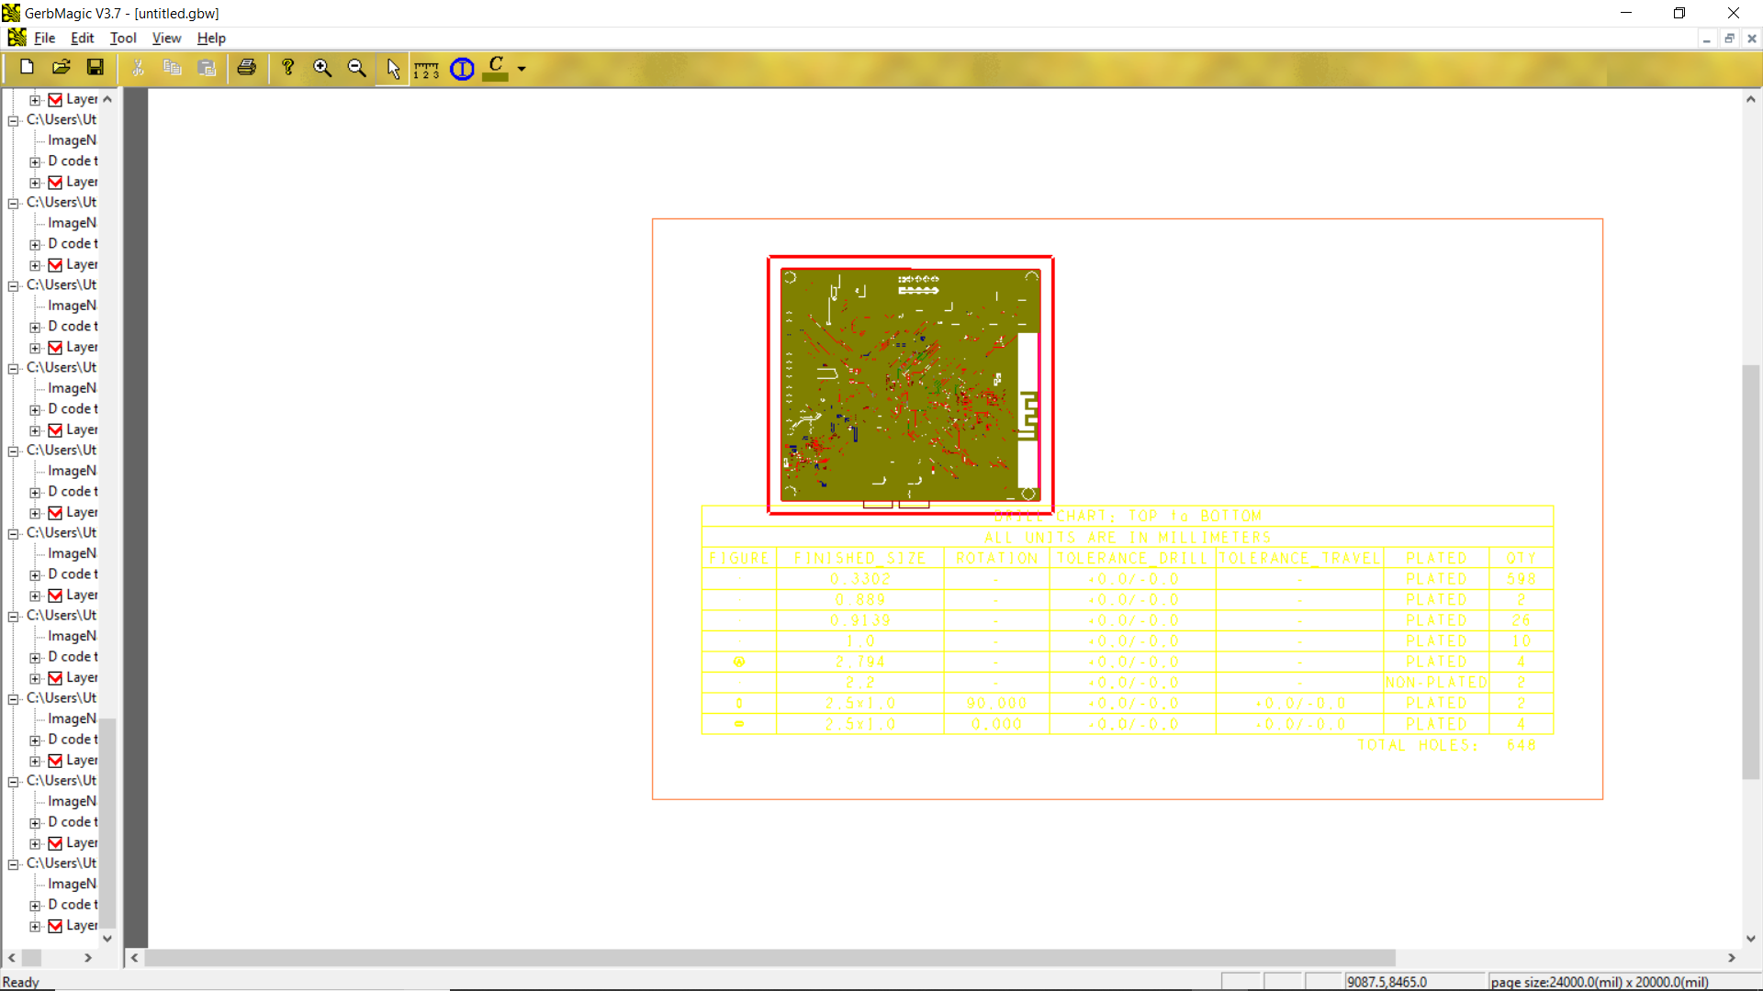

If it is OK, there will be No Error, see the outline and Drill Legend as the picture

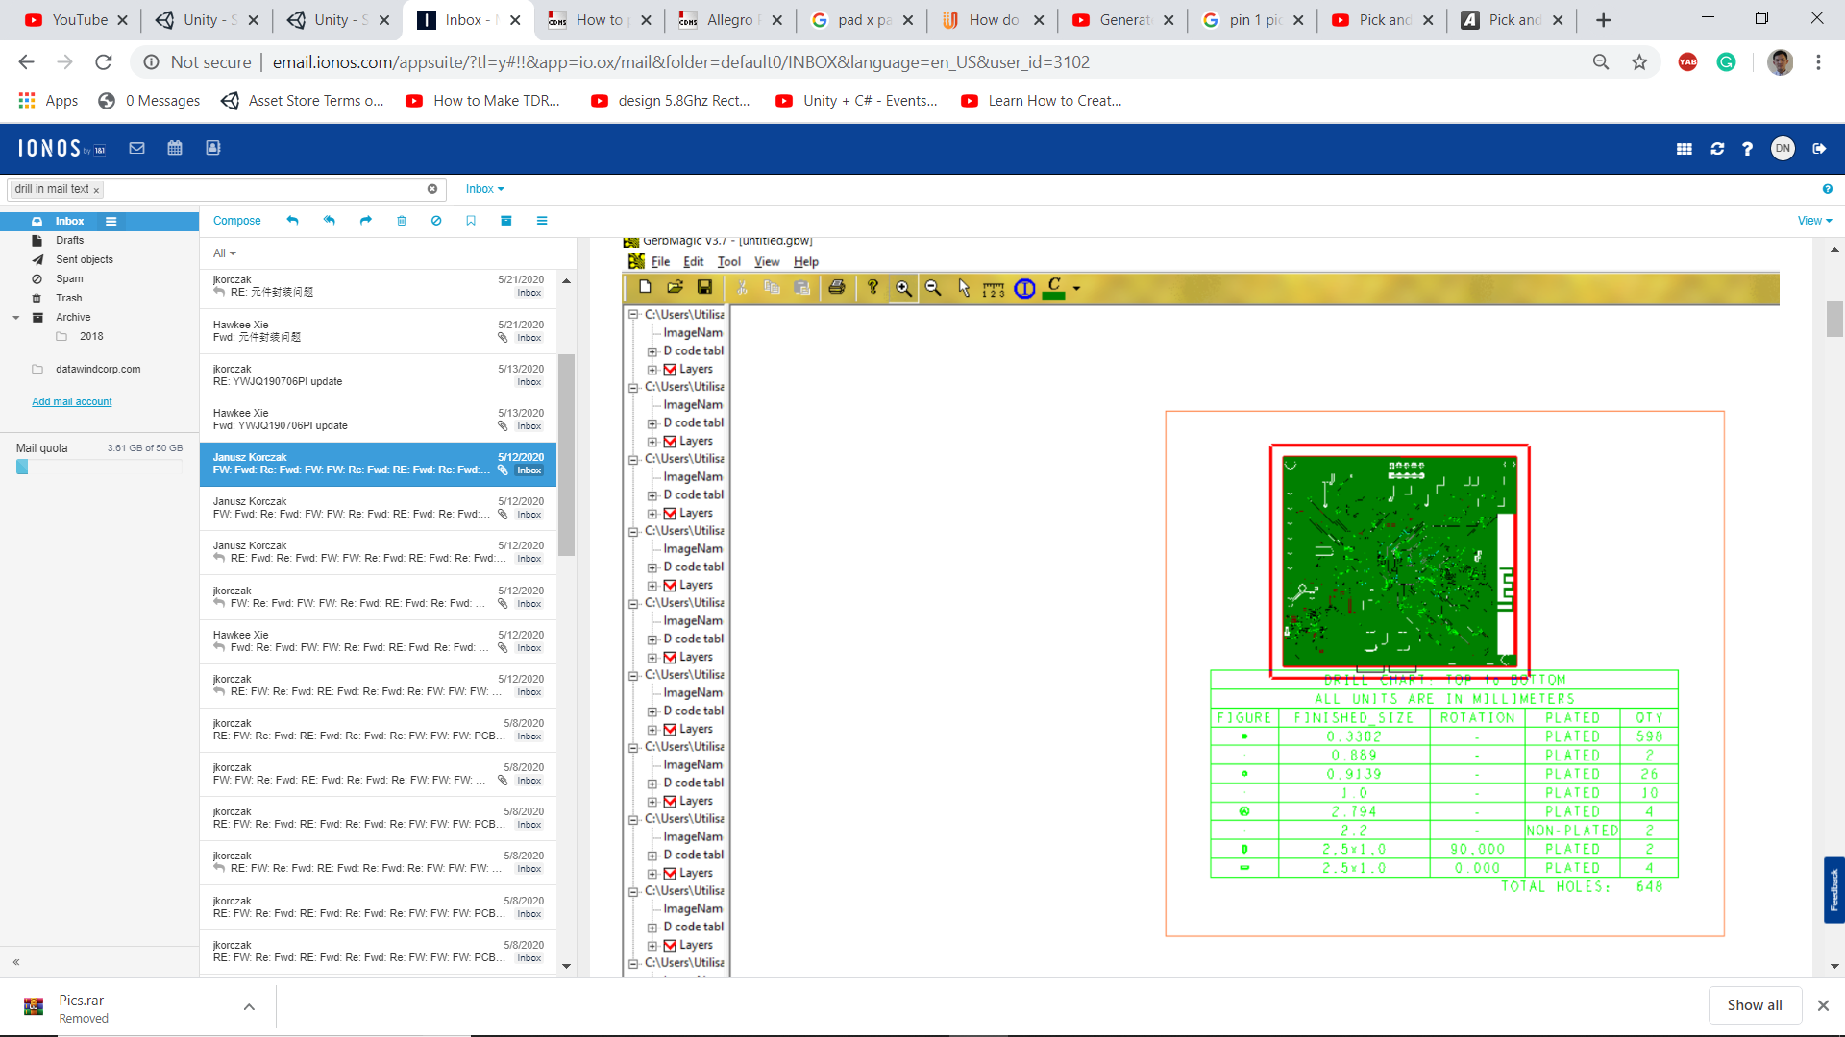

If it is OK, there will be No Error, see the outline and Drill Legend as the picture

# Pick and Place File Export

## First File

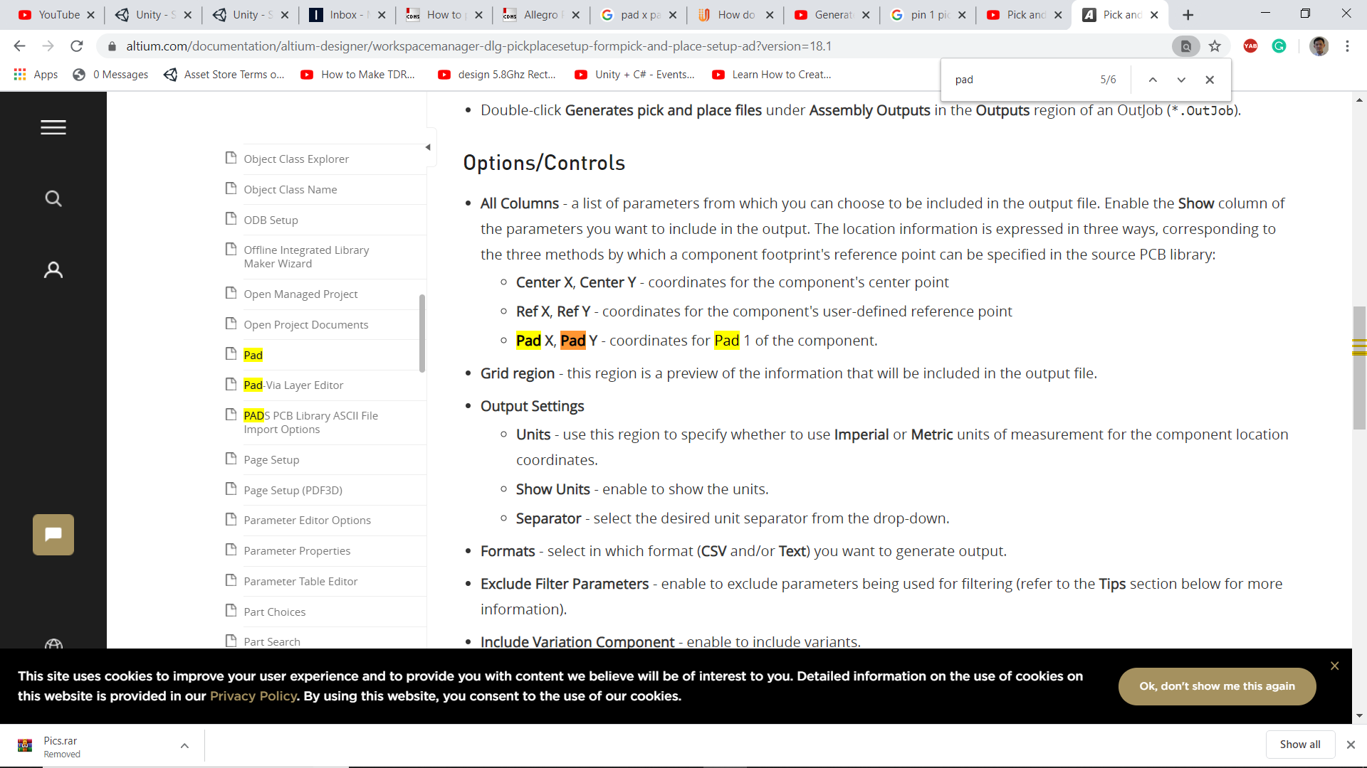

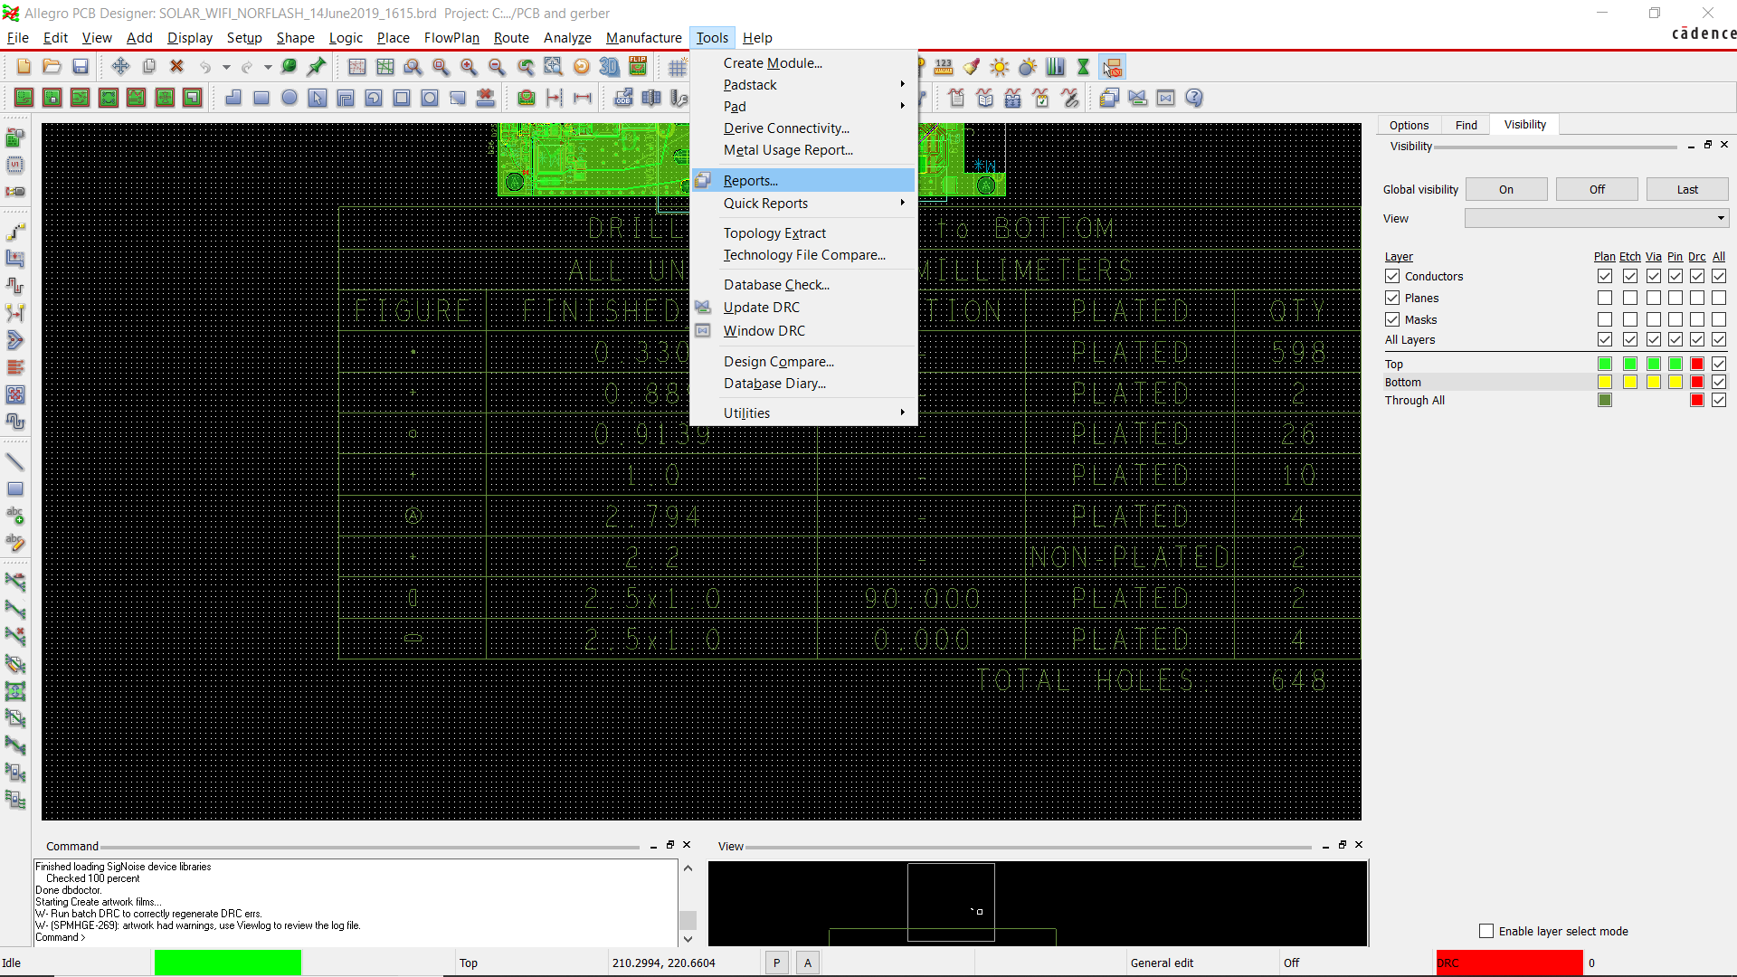

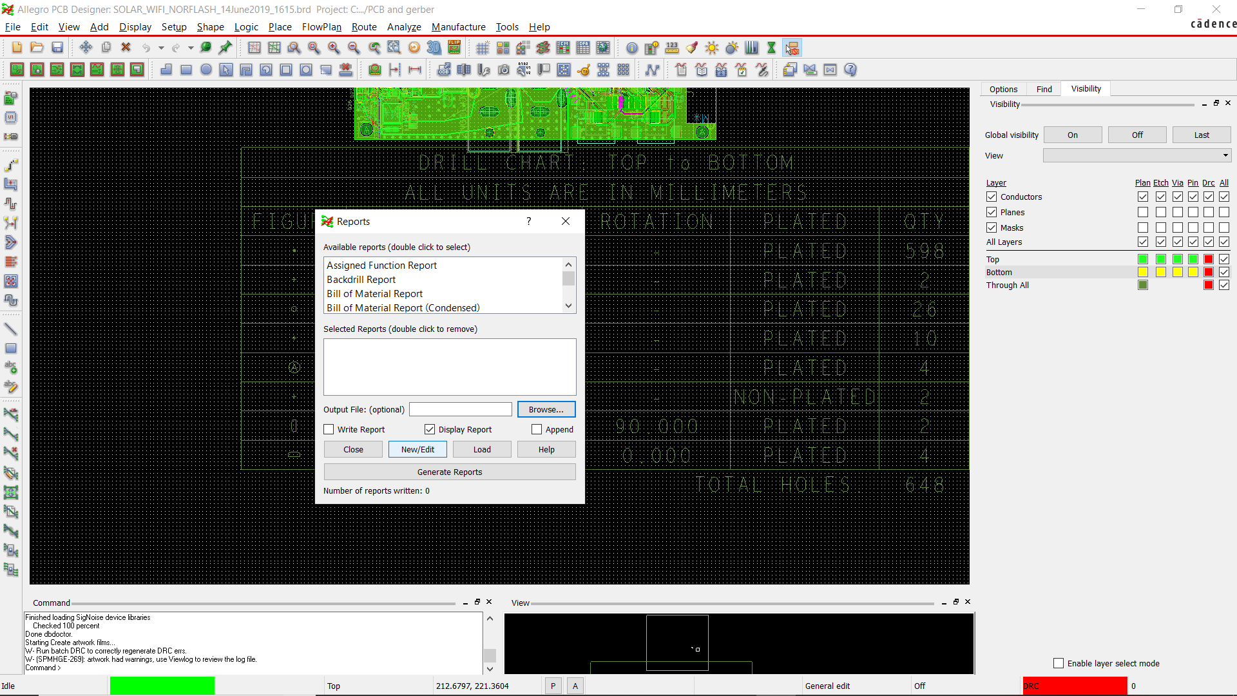

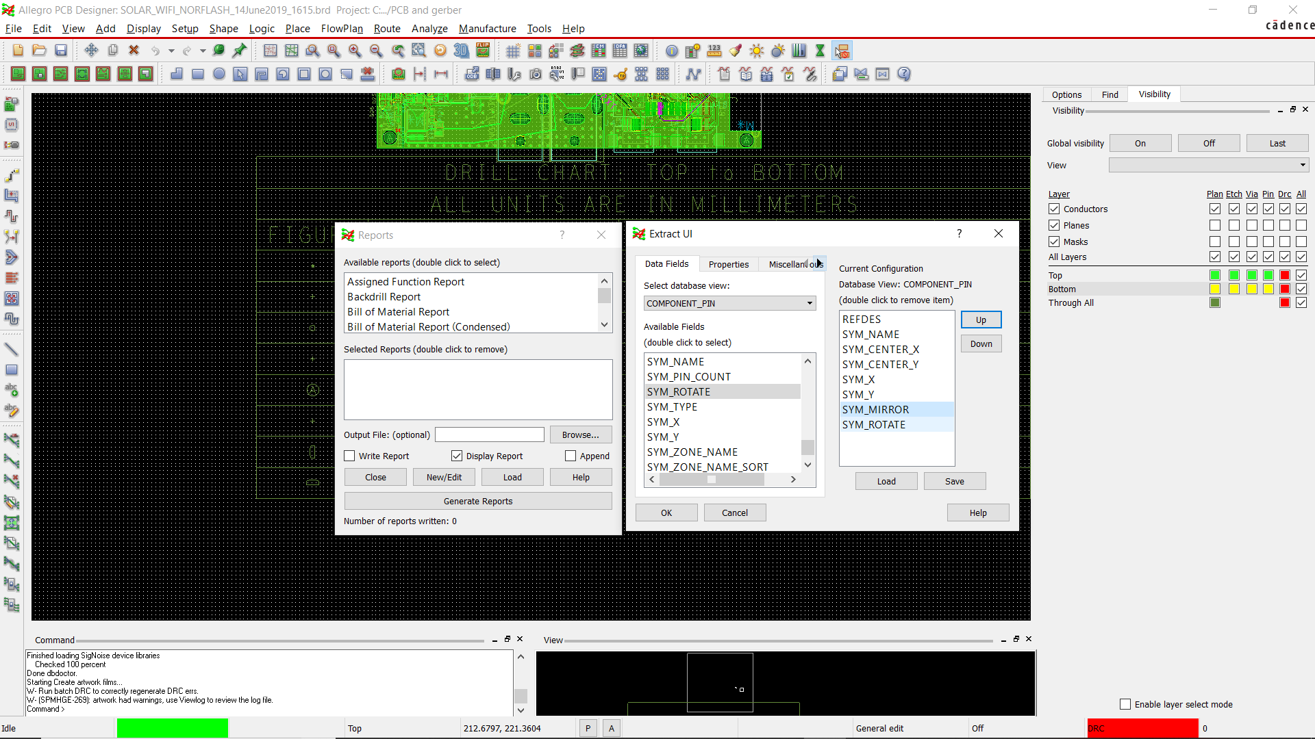

## Second File

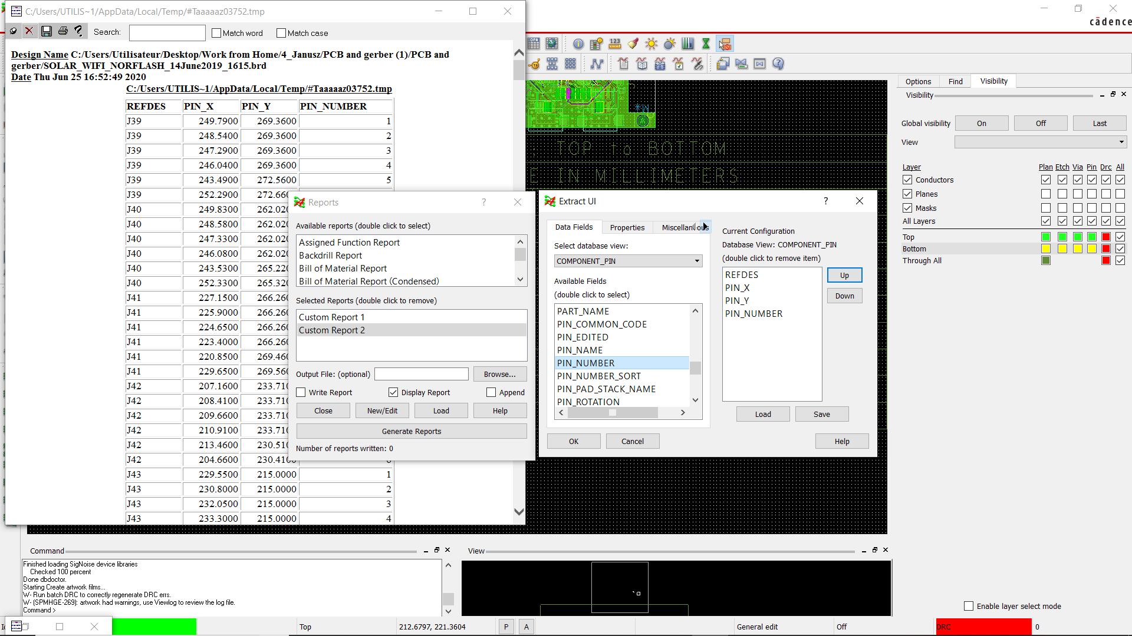

**Convert to Excel File, Add Table with Title and then sorting all pin 1s. Delete all Non #1 pin**

<https://www.convertcsv.com/html-table-to-csv.htm>

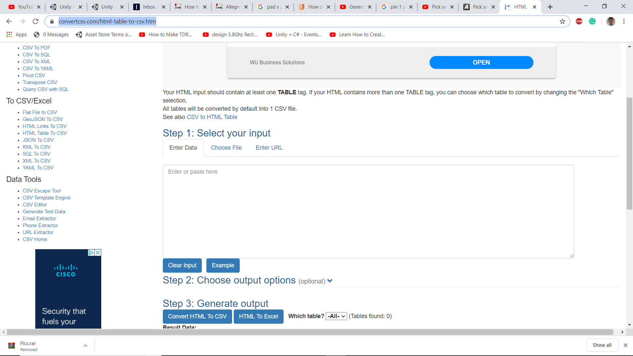

Merger this file with previous report file

# Silkscreen and symbol Icon for Assembly

The diode and Led icon on the PCB should be **diode icon (D25,D26,D30)**. Otherwise, the PCB maker does not understand

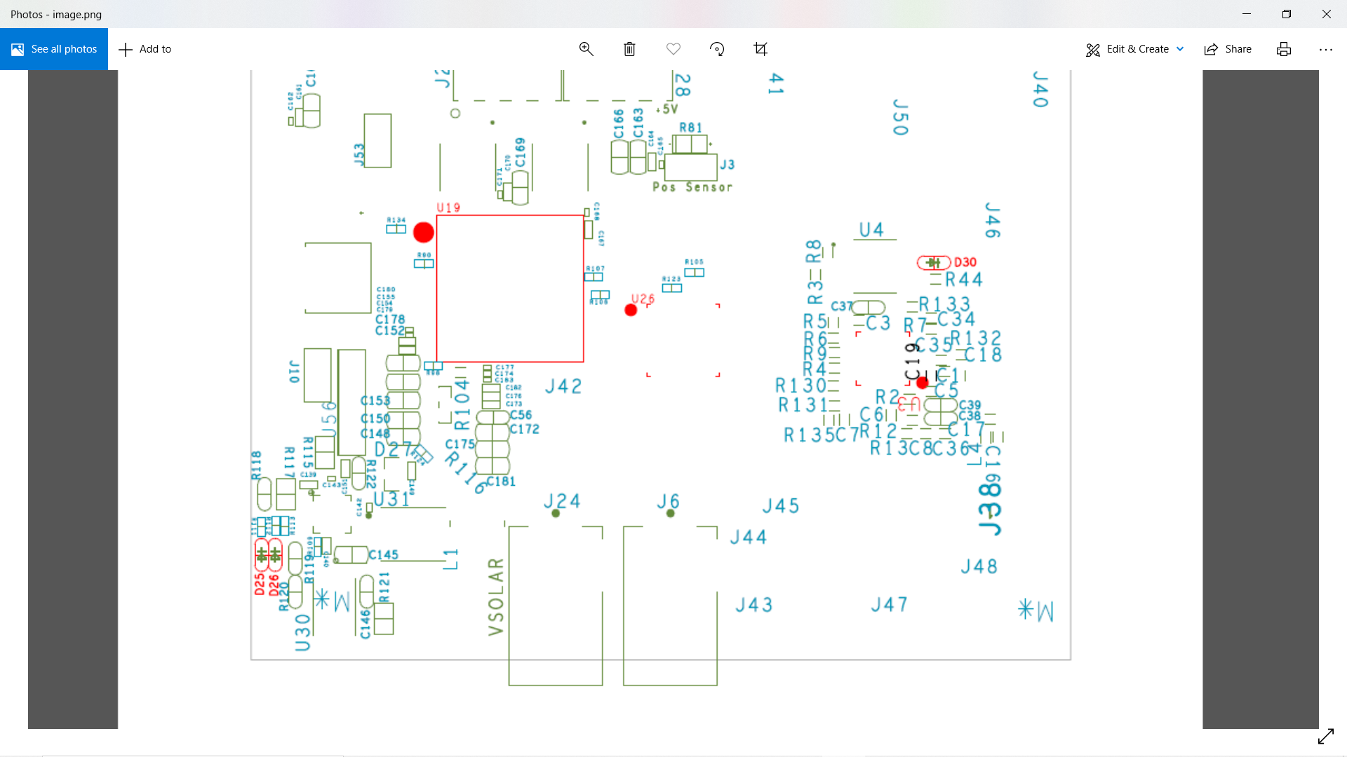

**GOOD SYMBOL**

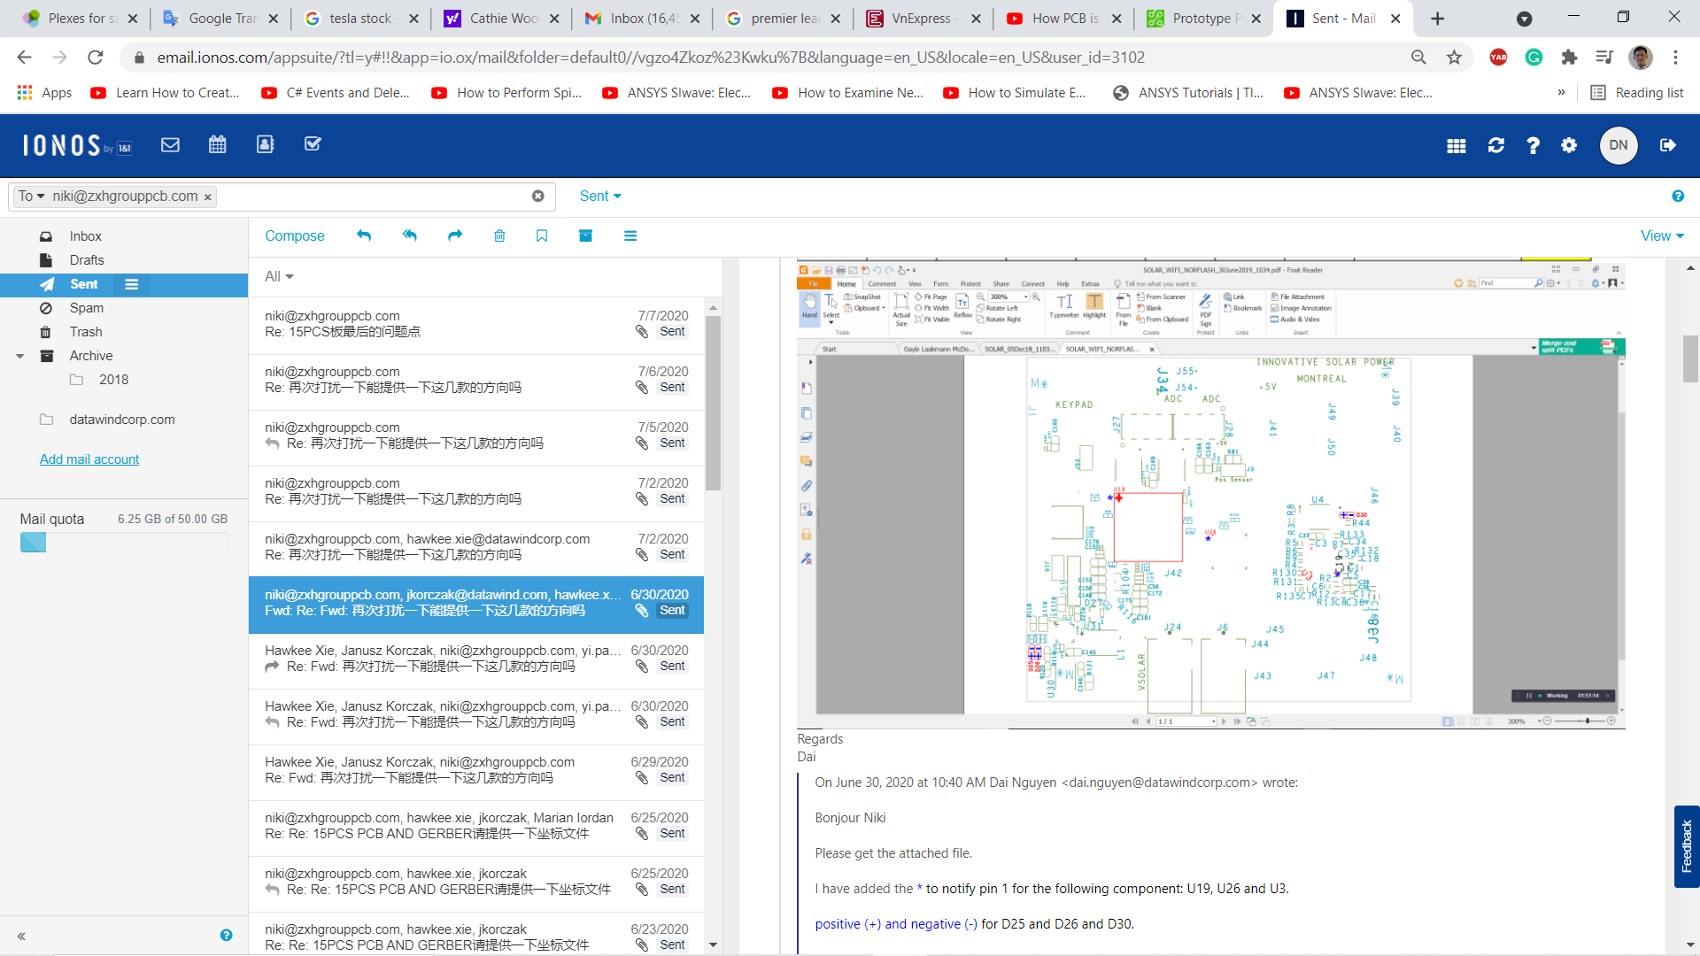

**BAD SYMBOL**